VPC CHELLANGES

Use Case: Setting up Transit Gateway and VPC Endpoints for a Multi-VPC Architecture
Scenario:
A large organization is migrating its on-premises infrastructure to the AWS cloud.
The organization's architecture involves multiple VPCs for different departments and applications, each requiring secure communication with centralized services and external resources.
The IT team needs to design and implement a scalable and efficient network architecture to accommodate the organization's growth and ensure robust connectivity between VPCs and external services.
Objectives:
- Design and deploy a scalable network architecture using AWS Transit Gateway to simplify network connectivity between multiple VPCs.
- Configure VPC endpoints to securely access AWS services without internet gateways or NAT gateways, ensuring data privacy and minimizing exposure to external threats.

Design and deploy a scaleable network architecture using aws transit gateway to simply network connectivity between multiple VPCs
- Go to the console and in search bar search VPC
- Click on VPC, VPC console will be open
- Click on vpc and click create a vpc
- Create 2 public vpc and 1 private
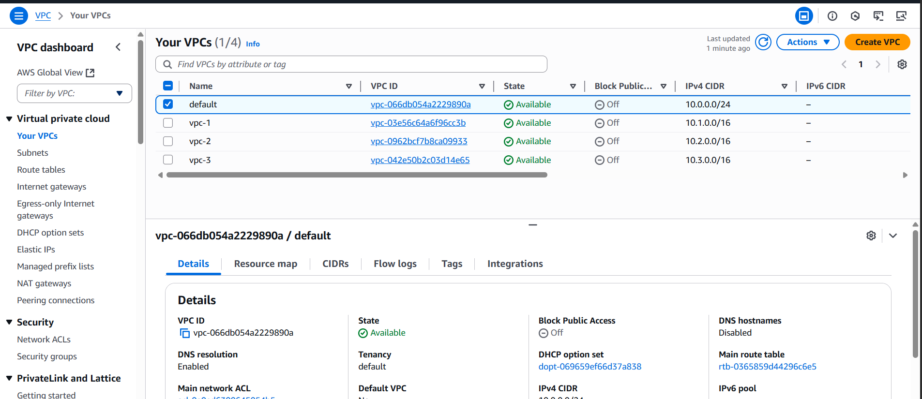
  - Click on subnets
  - And click on create subnets
  - Select VPC ID
  - And give subnet name
  - Give IPV4 Vpc CIDR Block
  - Click on create subnet
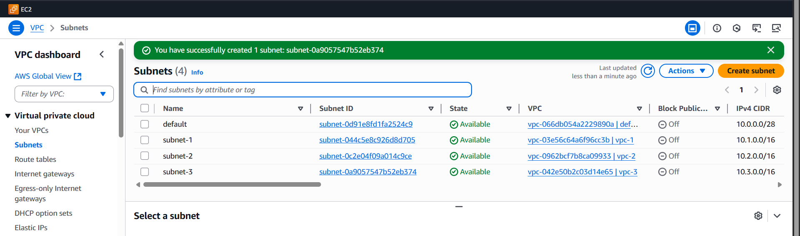
Go to the transit gateway
click on the transit gateway
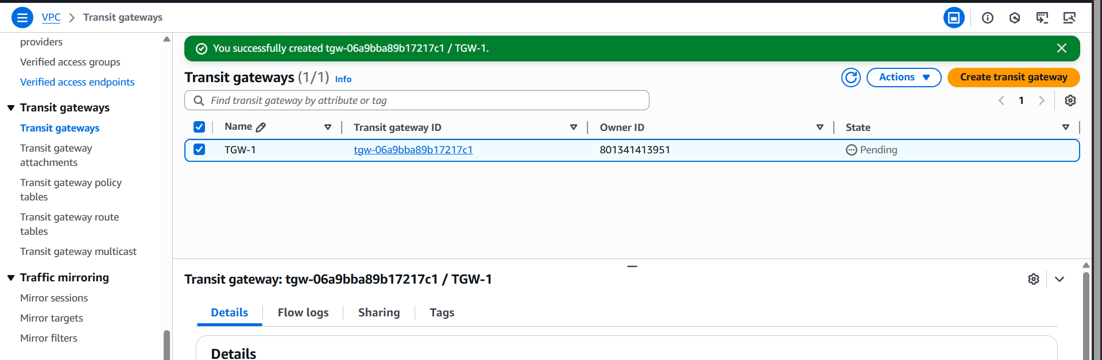
- Select the vpc for which youo want to attach
- and click the vpc create trasit gateway attachement

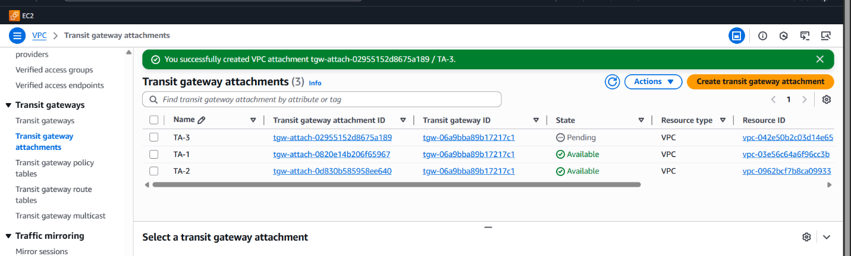
- Click on Route tables
- And click on create route table
- Give route table name and select vpc
- And click on create route table
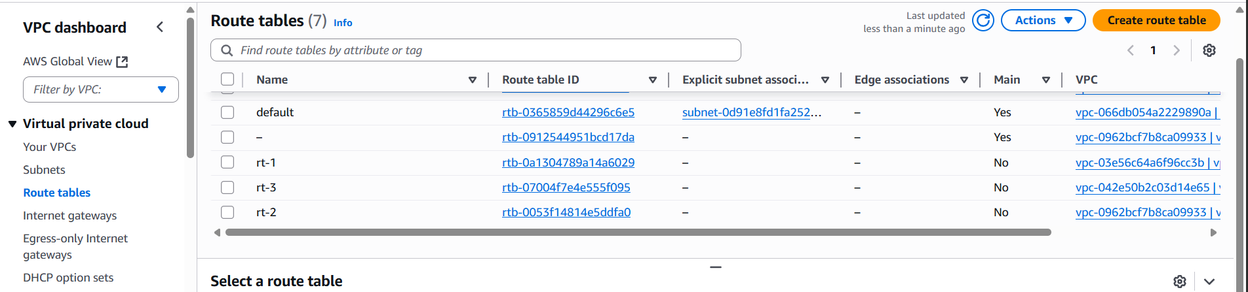
- And select route table and click on subnet associations, and add the subnets for each Route table.
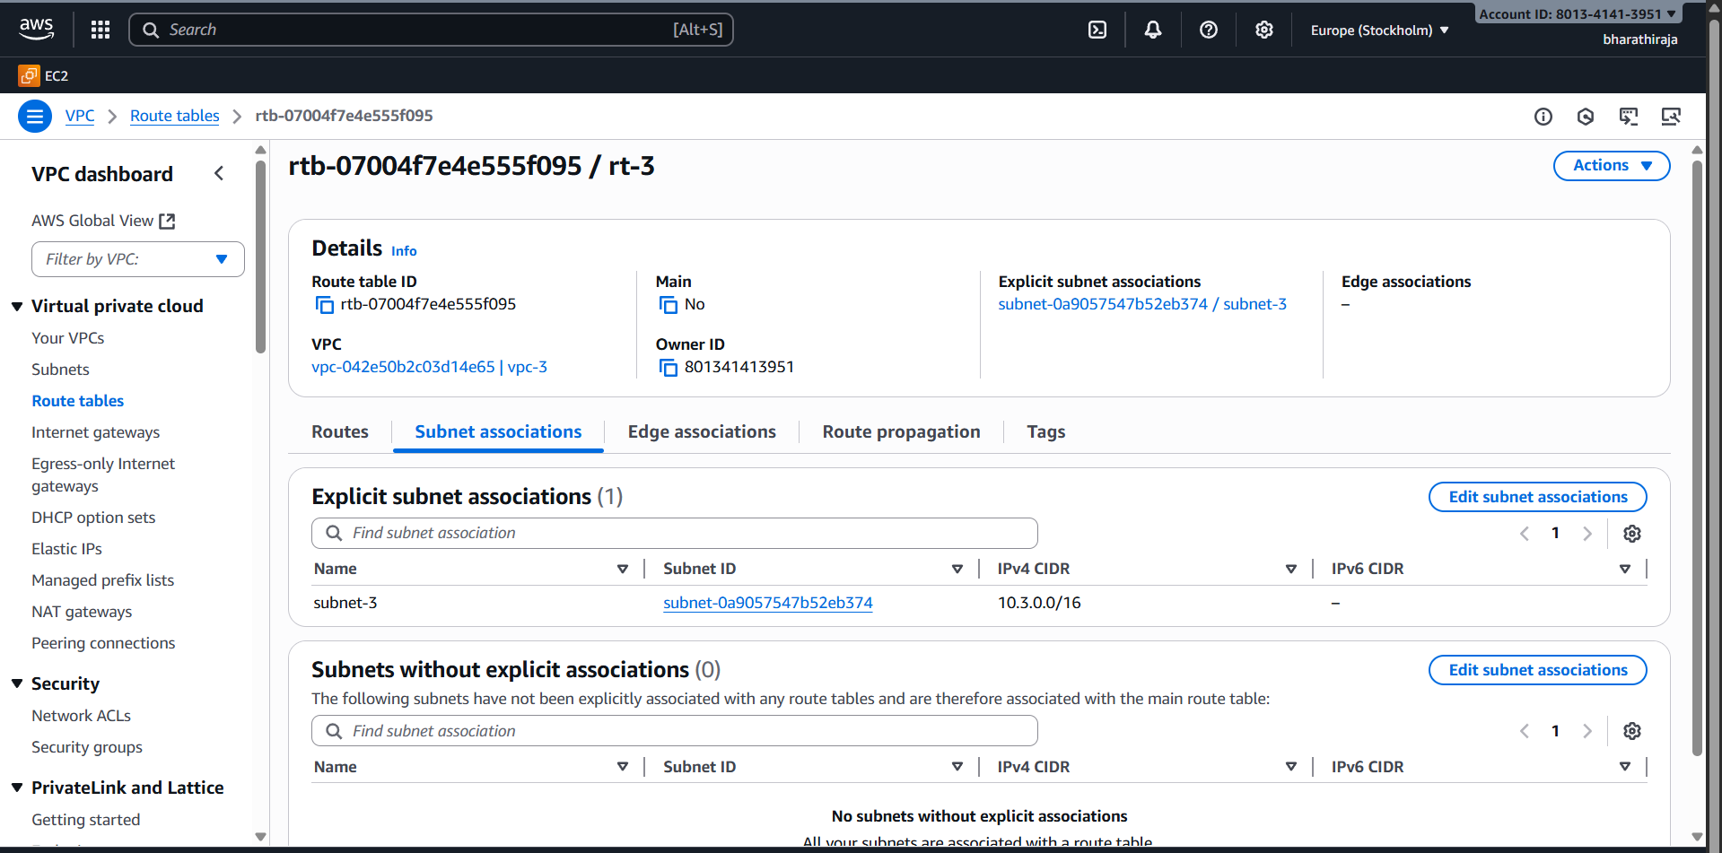
- Add internet gateway and add other two vpc,s CIDR range and attach transit gateway.
- Click on save changes
Add internet gate way and add other two vpc cidr range and attach transit gateway
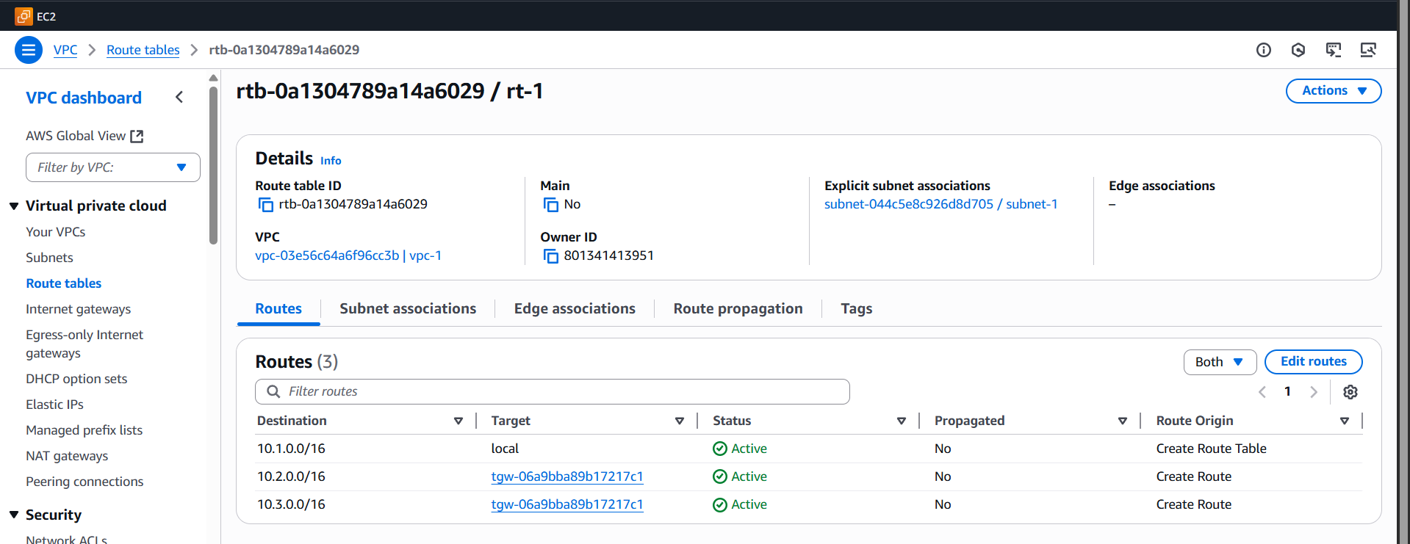

- Go to ec2 and launch 2 public instances and 1 private instance.
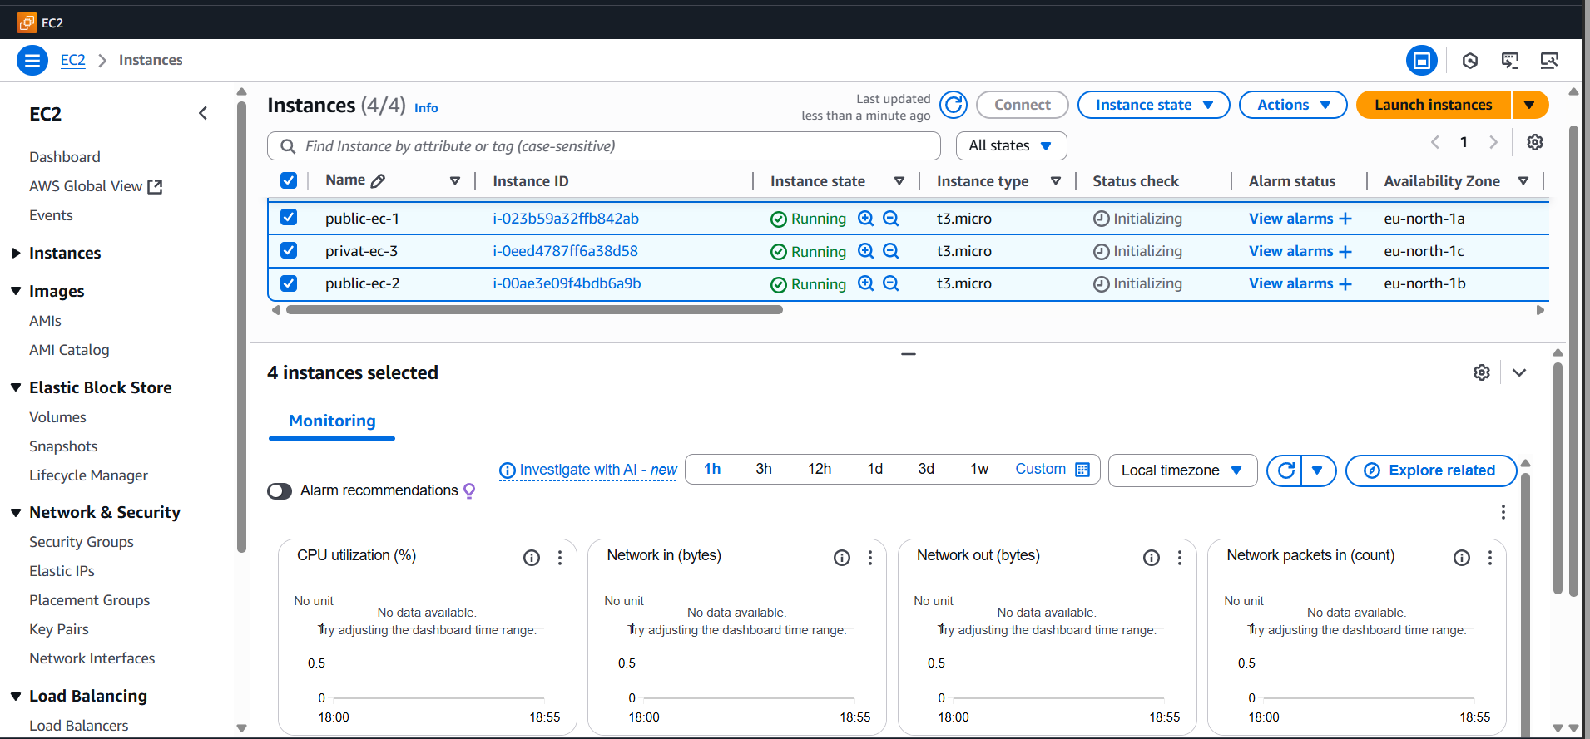
- Open gitbash and connect ssh with the public instance and ping private ip address of private instance .
Open the ssh – connect the public ip and ping the ip address

- In this way we have to edit routes for RT-01 & RT-02 and RT-03 route table is private, so we don’t need to attach internet gateway.
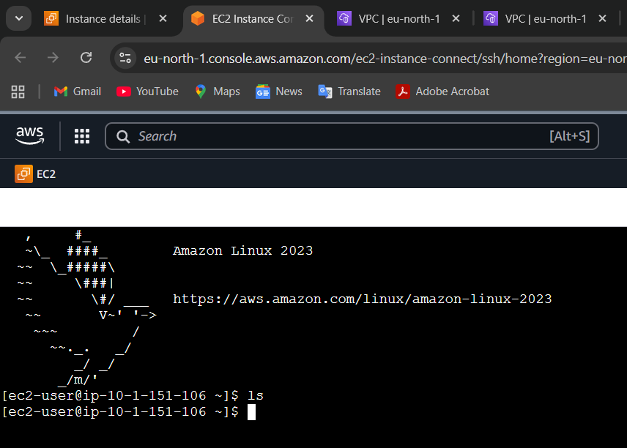
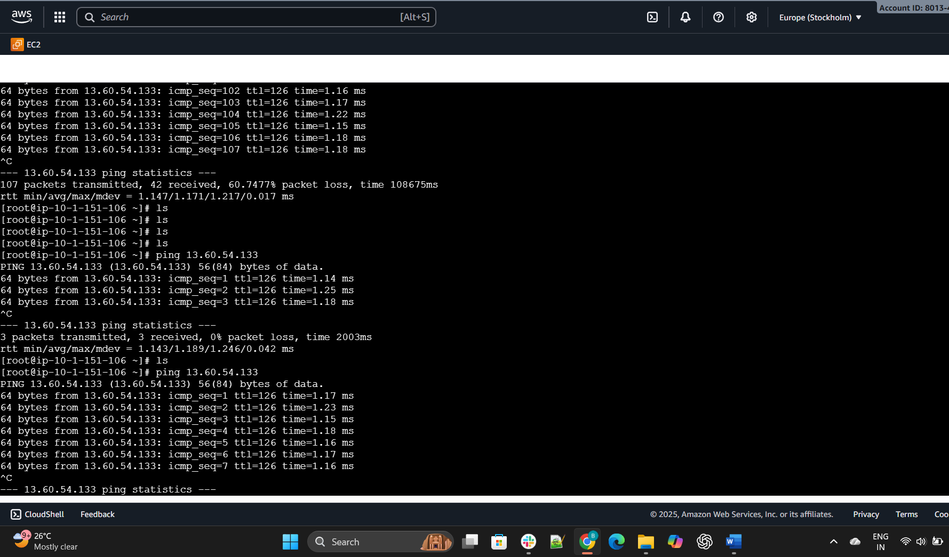

2 ) Configure VPC endpoints to securely access AWS services
without internet gateways or NAT gateways, ensuring data
privacy and minimizing exposure to external threats.
Launch one public instance and one private instance using

private subnet and public subnetCopy the pem key in local and create a file and paste the pem
key in that file.
Add permission to that file chmod 400 test.pem
Ssh -i test.pem ec2-user@<private ip>
After that aws configure.

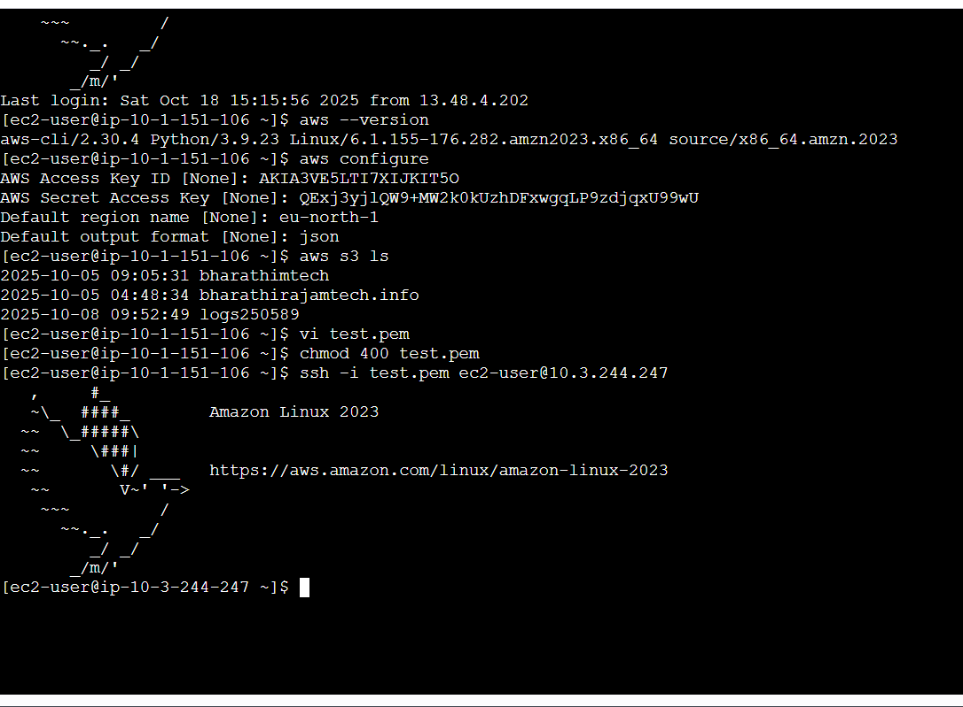
Now go to vpc
• Navigate to end points
• Select aws service
• Then select s3 and end point type expres
• Then select gateway
•Create end point the end point has been created
•Now you can acess the s3 from the private instance : aws
s3 ls
Create an end point.
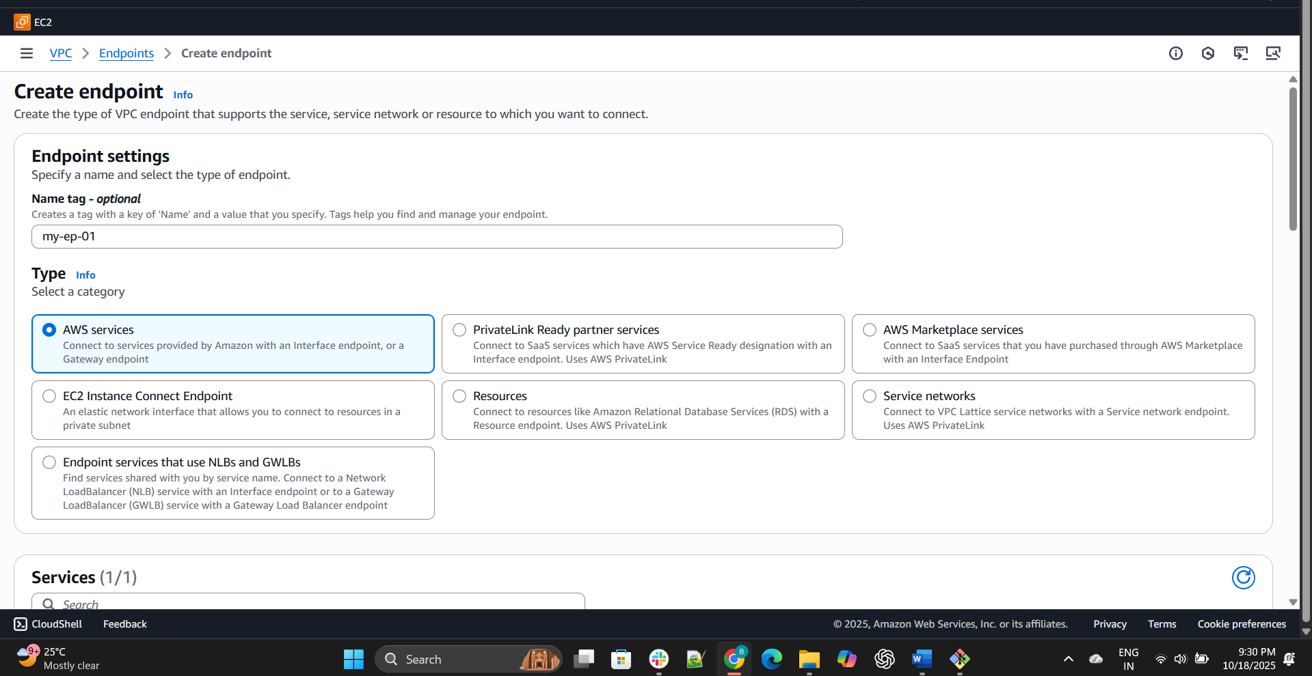
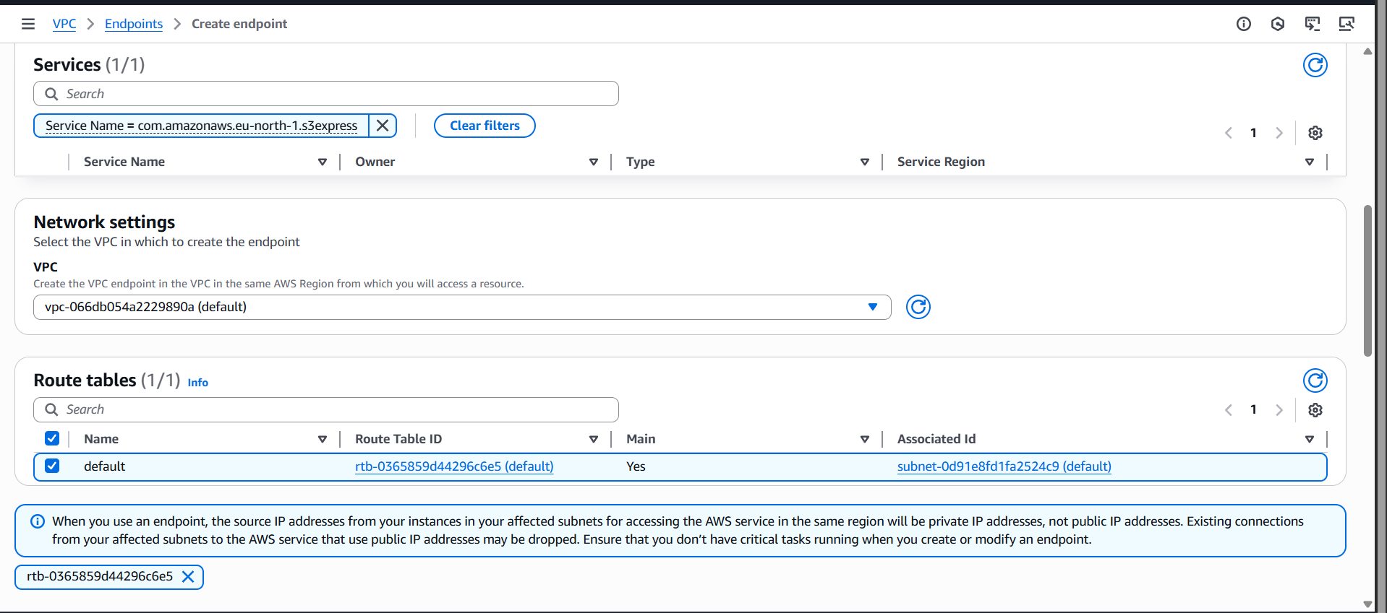

Default that one
